

Need to remove shed number, change all sheds to choose sheds
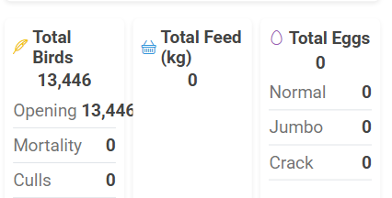
change layout to display each card one by one in mobile view
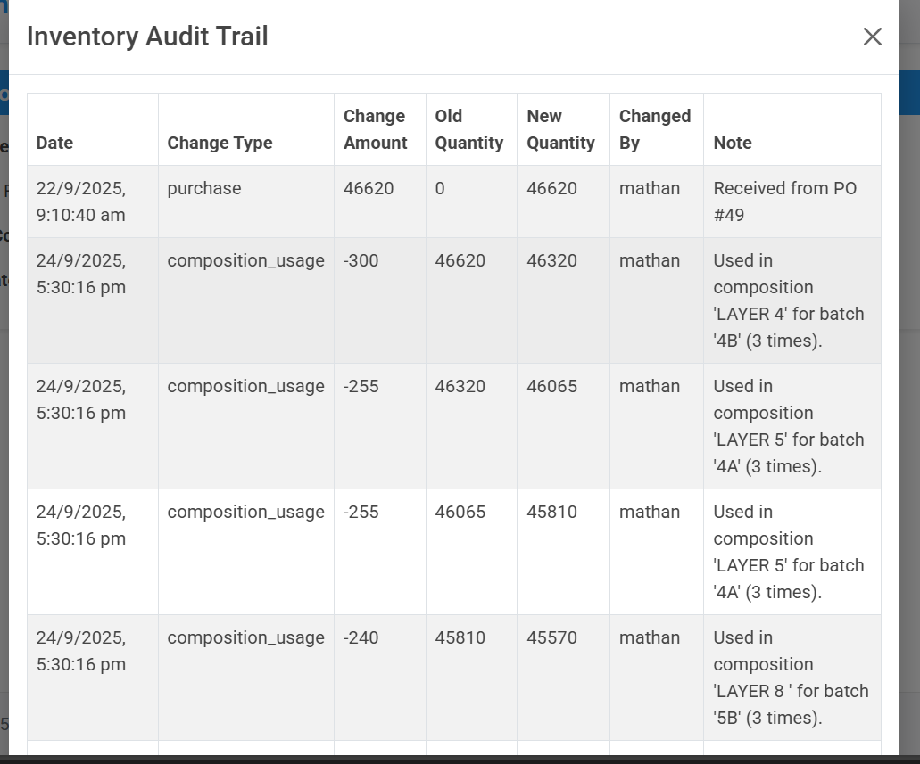
make it like pagination and export

change audit trail to report like other screens


Move to left

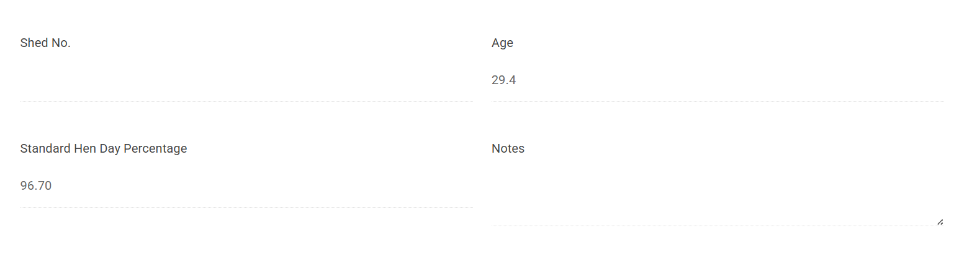
put it in a container

Remove filter by category
change all categories to choose category
report required for sales and purchase and inventory
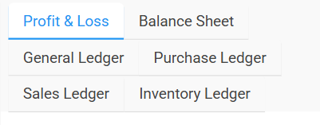

Change alignment
use suggested date bug in egg room report

